

Project Title: ENTERPRISE HOSPITAL MANAGEMENT SYSTEM
Student Name: Maryam Allah Ditta (233506)
Muhammad Haroon (233504)
Section: BSCS (B)
Teacher Name : Sir Rashaf

Table of Contents
1. System Overview & Core Architecture
- 1.1 Security & Authentication Framework
- 1.1.1 Administrative Gatekeeping
- 1.1.2 Session Persistence
- 1.1.3 Encryption Aesthetics
2. Administrator Control Center (Global Overseer)
- 2.1 Personnel Verification Queue
- 2.2 Global Personnel Directory
- 2.3 Security Audit Logs
3. Doctor Module (Clinical Suite & AI Diagnostics)
- 3.1 Synchronized Appointment Manager
- 3.2 Consultation Node
- 3.3 Neural Insight Engine (Gemini AI Integration)
- 3.3.1 Technology
- 3.3.2 Function
- 3.3.3 Impact
- 3.4 Electronic Prescription (e-Rx)
4. Nurse Module (Station & Patient Monitoring)
- 4.1 Dynamic Task Queue
- 4.2 Medication Handover Protocol
- 4.2.1 Dispatch Notification
- 4.2.2 Physical Administration & Approval
- 4.2.3 Confirmation Loop
- • 4.3 System Alert Node
5. Clinical & Pharmacy Module (Logistics)
- 5.1 Pharmacy Fulfillment Queue
- 5.2 Dispatch System
- 5.3 Inventory Level Monitoring
6. Accountant Module (Finance & Global Ledger)
- 6.1 Multi-Currency Engine
- 6.2 Financial Health Statistics
- 6.3 Transaction Master Ledger
7. Patient Module (Transparency Portal)
- 7.1 Encrypted Medical History
- 7.2 Live Medication Tracker
- 7.3 Financial Statements
- 7.4 Appointment Hub
8. Universal Shared Systems
- 8.1 Secure Chat Interface
- 8.2 Global Notification System
- 8.3 Aesthetic Design & UX Philosophy

Project Report :

MEDCORE PRO: ENTERPRISE HOSPITAL MANAGEMENT SYSTEM

1. System Overview & Core Architecture

MedCore Pro is a sophisticated, multi-role medical operating system designed to digitize every facet of hospital operations. The system is built on a Role-Based Access Control (RBAC) architecture, ensuring data isolation and security.

1.1 Security & Authentication Framework
1.1.1 Administrative Gatekeeping
Unlike traditional systems, MedCore Pro requires manual verification. New users (Doctors, Nurses, etc.) enter a PENDING state. Access to internal modules is restricted until an Administrator reviews the signature and upgrades the status to APPROVED.
1.1.2 Session Persistence
Using a custom database engine (store.ts), the system maintains a persistent state. Patient histories, financial ledgers, and chat logs remain intact even after browser restarts.
1.1.3 Encryption Aesthetics
The user interface follows a Cyber-Security theme, utilizing indigo-950 backgrounds and blurred glassmorphism to emphasize a high-security environment.

2. Administrator Control Center (Global Overseer)
The Administrator module acts as the system’s Root Node, providing centralized oversight of personnel and security.

2.1 Personnel Verification Queue
Incoming requests are displayed in a structured interface where administrators can authenticate or decline signatures, preventing unauthorized access to clinical data.

2.2 Global Personnel Directory
A master directory provides visibility of all staff members and patients. Administrators can edit access rights, view doctor specializations, and manage user accounts.

2.3 Security Audit Logs
A real-time terminal window tracks critical system events, including:
- Terminal session initializations
- Neural Engine (AI) queries
- Inventory synchronization events
- Credential updates

3. Doctor Module (Clinical Suite & AI Diagnostics)
The Doctor dashboard is optimized for clinical decision-making and patient management.

3.1 Synchronized Appointment Manager
Doctors can view daily schedules, filter appointments by status (Scheduled or Completed), and edit session details such as date, time, and reason.

3.2 Consultation Node
A dedicated high-focus workspace allows doctors to record clinical findings.

3.3 Neural Insight Engine (Gemini AI Integration)
3.3.1 Technology
Uses gemini-3-flash-preview.
3.3.2 Function
Doctors input symptomology, and the AI provides professional summaries, diagnostic considerations, and differential paths.
3.3.3 Impact
Reduces clinical cognitive load and offers a rapid second opinion for complex cases.

3.4 Electronic Prescription (e-Rx)
Upon finalizing a diagnosis, doctors generate digital prescriptions that are automatically transmitted to the Pharmacy module and stored in patient history.

4. Nurse Module (Station & Patient Monitoring)
The Nurse dashboard supports frontline execution of treatment plans and medication safety.

4.1 Dynamic Task Queue
Nurses manage a real-time list of clinical tasks, toggling them between Todo and Done with instant updates.

4.2 Medication Handover Protocol
4.2.1 Dispatch Notification
When medicine is dispatched by the Clinical module, nurses receive an urgent notification.
4.2.2 Physical Administration & Approval
After administering the medicine, the nurse confirms handover via the system.
4.2.3 Confirmation Loop
The medicine status updates to RECEIVED, and the prescribing doctor is notified.

4.3 System Alert Node
Displays high-priority system messages and emergency updates.

5. Clinical & Pharmacy Module (Logistics)
Clinical specialists manage prescription fulfillment and inventory logistics.

5.1 Pharmacy Fulfillment Queue
Displays all active prescriptions, including patient names, medication details, and dosages.

5.2 Dispatch System
Clinical staff dispatch medicines, triggering nurse station notifications.

5.3 Inventory Level Monitoring
Tracks essential supplies and displays warnings when stock falls below critical thresholds.

6. Accountant Module (Finance & Global Ledger)
The financial module manages the hospital’s revenue cycle.

6.1 Multi-Currency Engine
The ledger supports PKR, USD, EUR, GBP, AED, and SAR with dynamic exchange calculations.

6.2 Financial Health Statistics
Dashboard indicators show total volume, settled payments, and unpaid arrears.

6.3 Transaction Master Ledger
Maintains a detailed history of all generated bills with invoice IDs and settlement status.

7. Patient Module (Transparency Portal)
The Patient portal provides full access to medical and financial data.

7.1 Encrypted Medical History
Chronological view of diagnoses, treatments, and doctor notes.

7.2 Live Medication Tracker
Tracks medicine status as Pending, Dispatched, or Received.

7.3 Financial Statements
Displays billing history and payment status.

7.4 Appointment Hub
Allows patients to monitor upcoming consultations.

8. Universal Shared Systems

8.1 Secure Chat Interface
Role-specific communication ensures professionalism. Messages are delivered in real time with timestamps and unread indicators.

8.2 Global Notification System
Context-aware alerts are delivered per role, with persistent badge counts.

8.3 Aesthetic Design & UX Philosophy
The system follows a Cyber-Clinical High-Performance theme using indigo, slate, and emerald color palettes with glassmorphism and subtle 3D effects

HOSPITAL PORTAL :
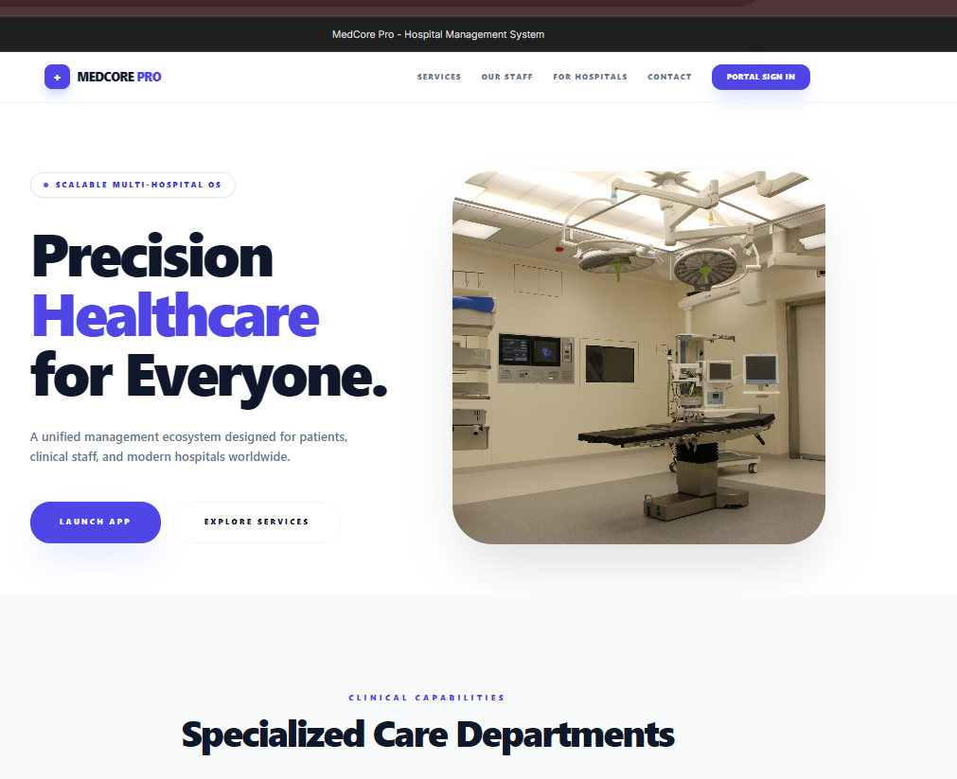
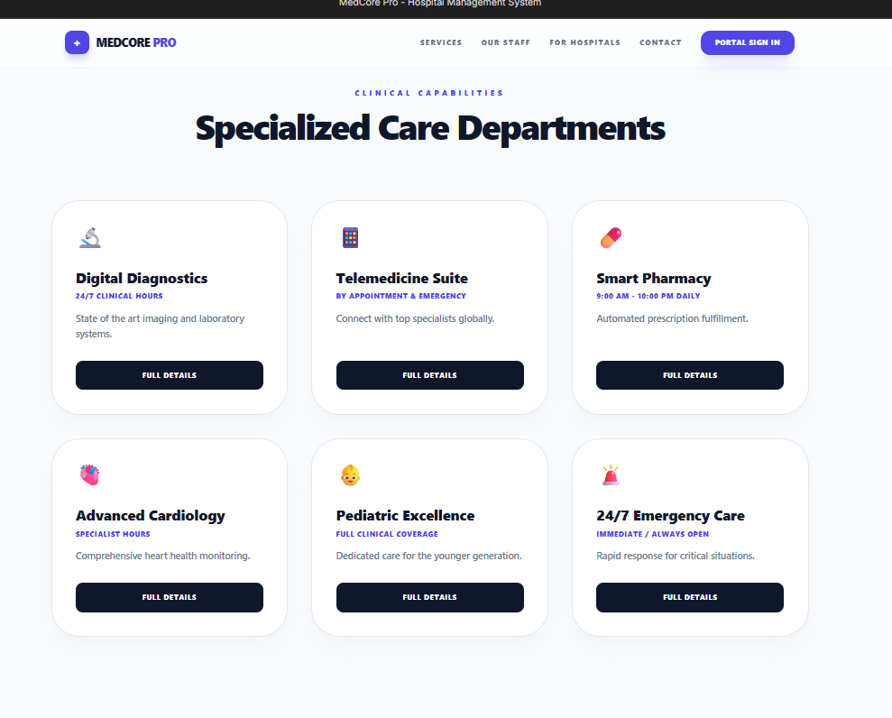
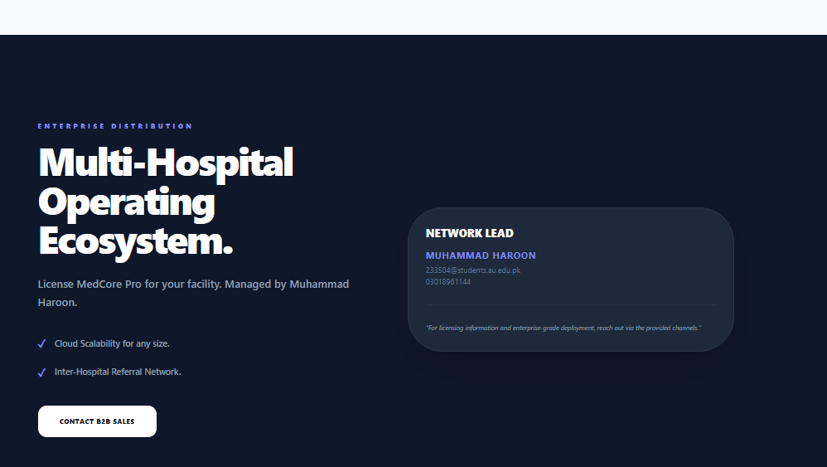
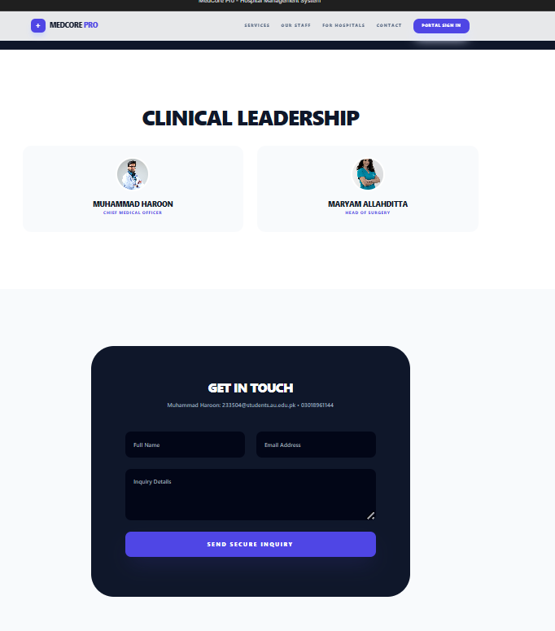

ADMINISTRATOR LOGIN :
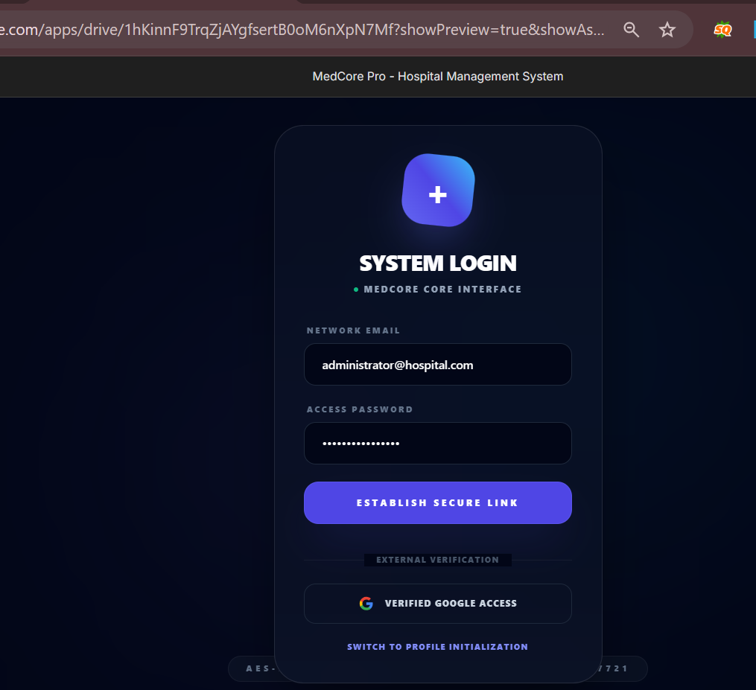
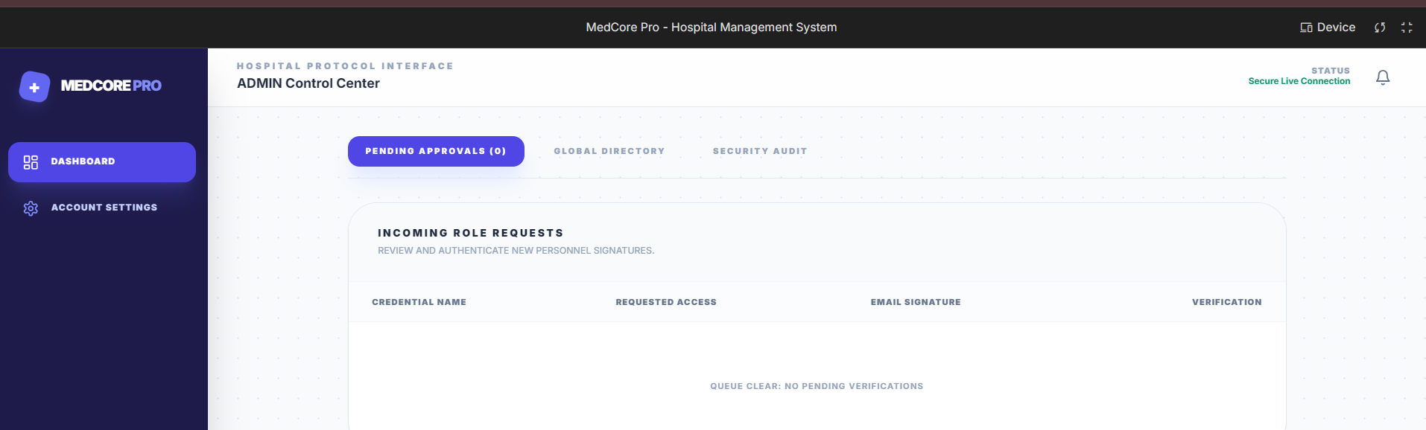
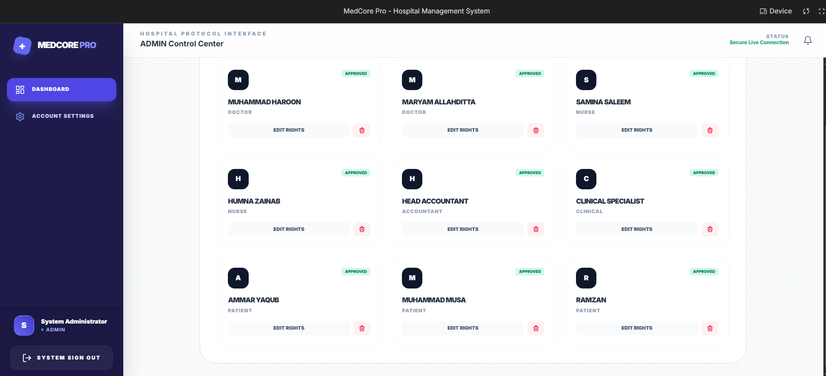
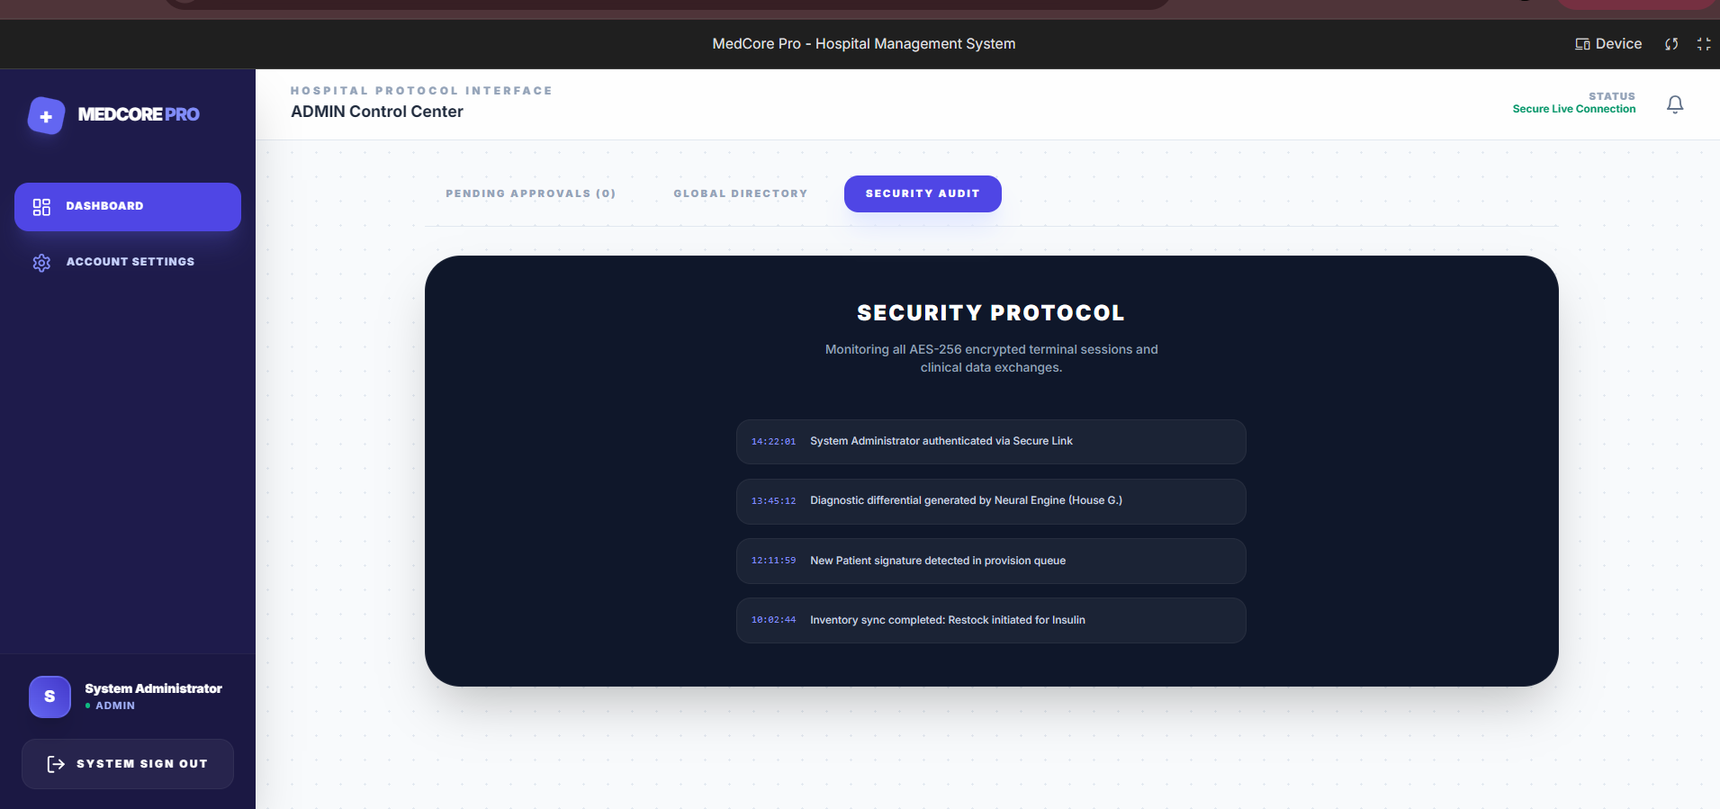
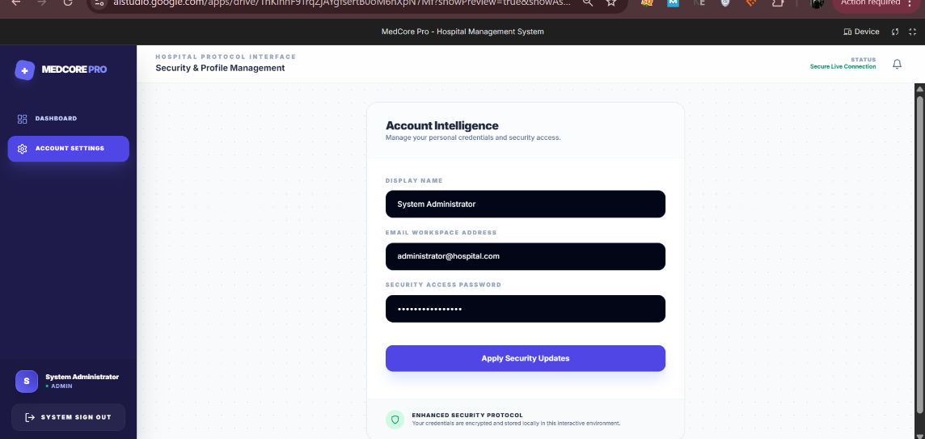
DOCTOR LOGIN :
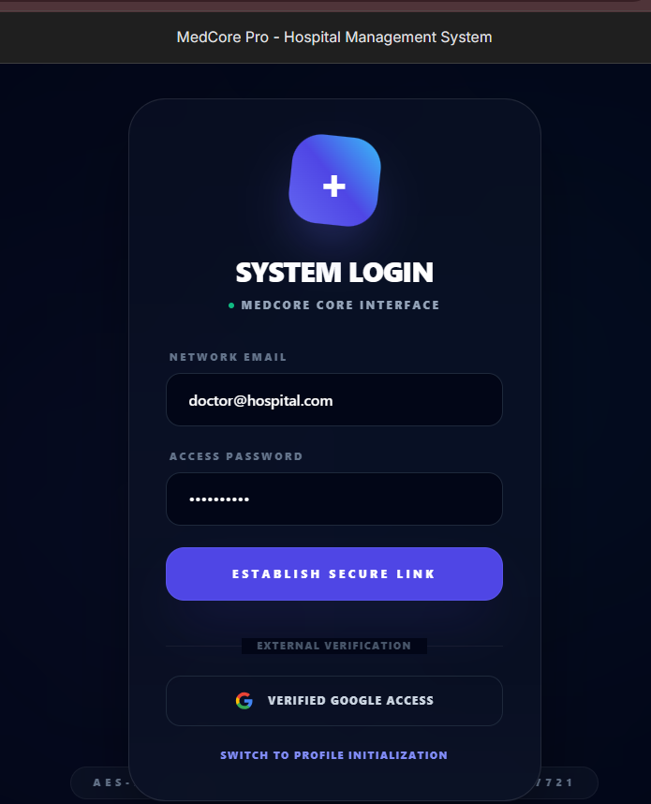
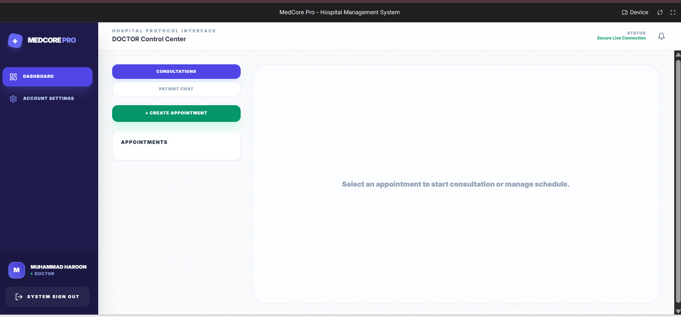
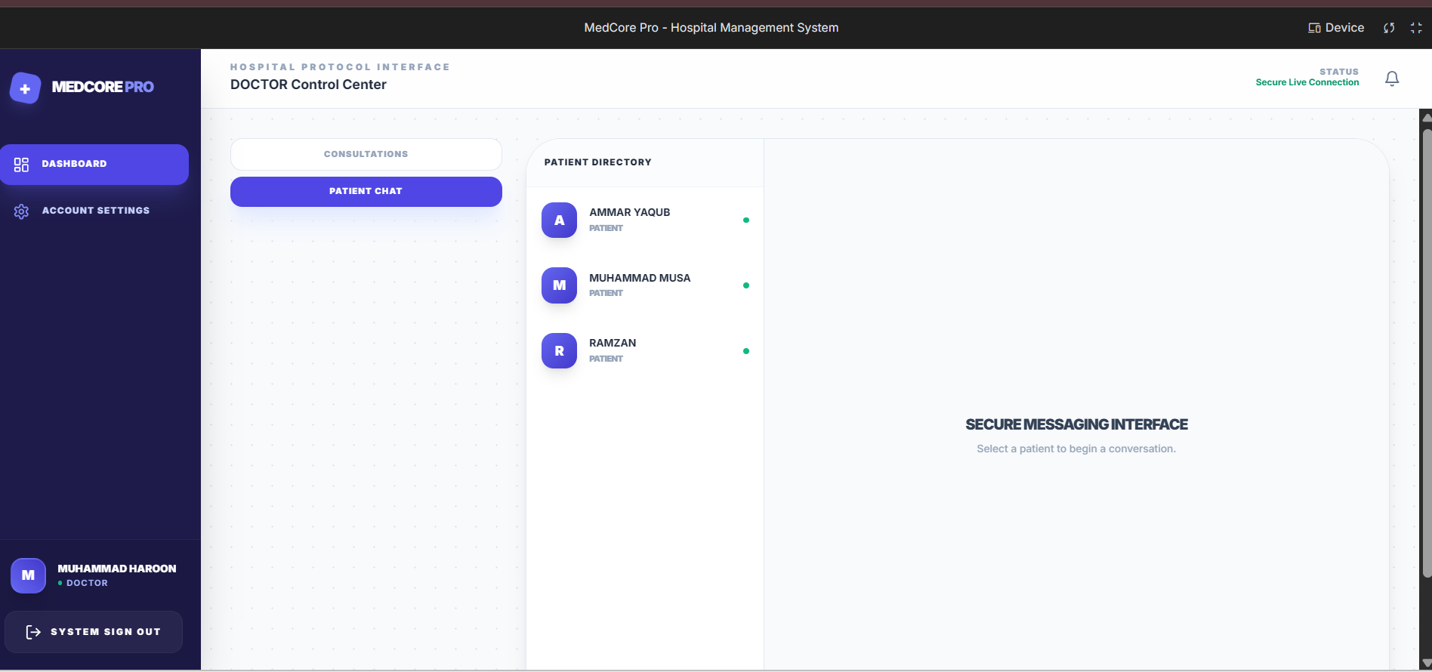
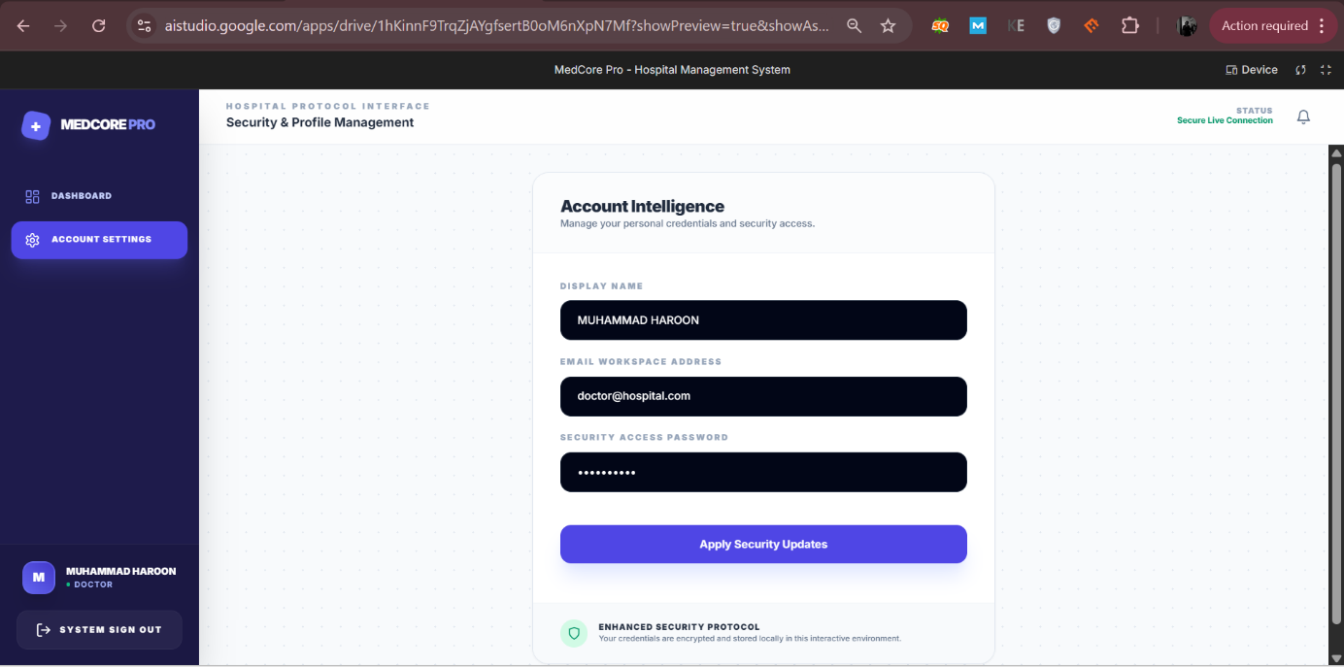

NURSE LOGIN :
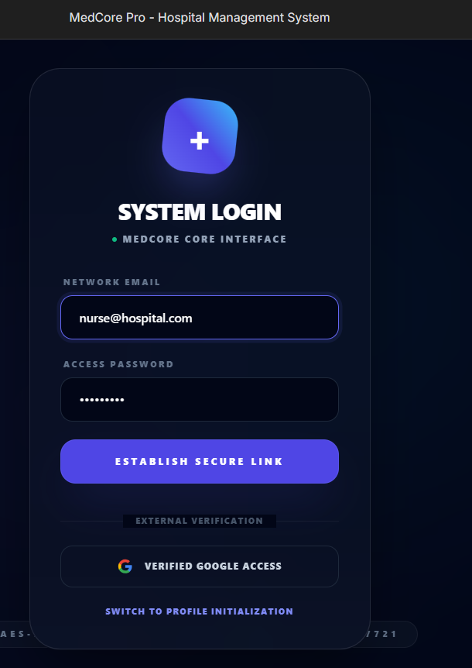
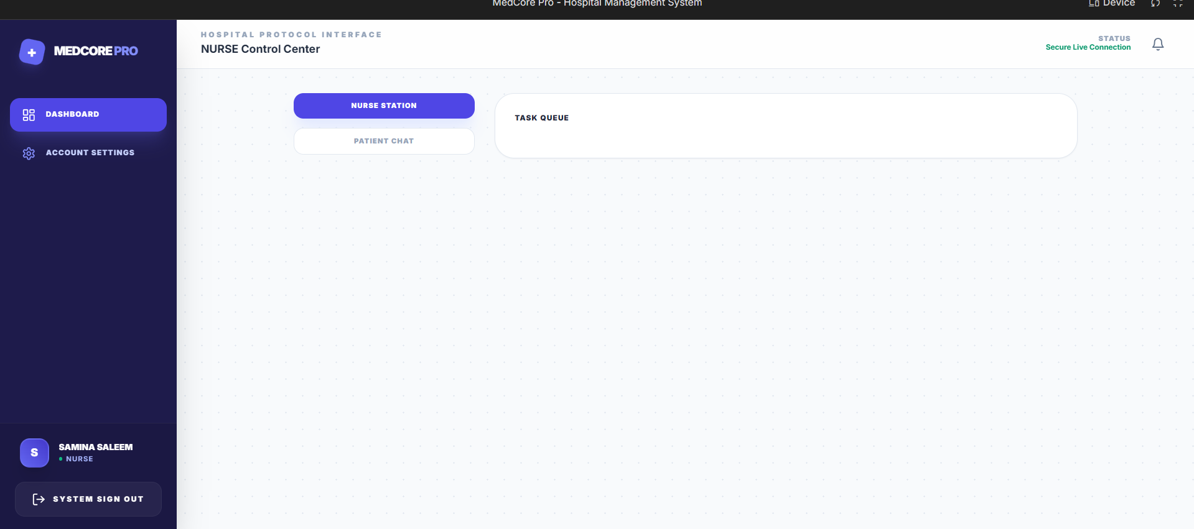
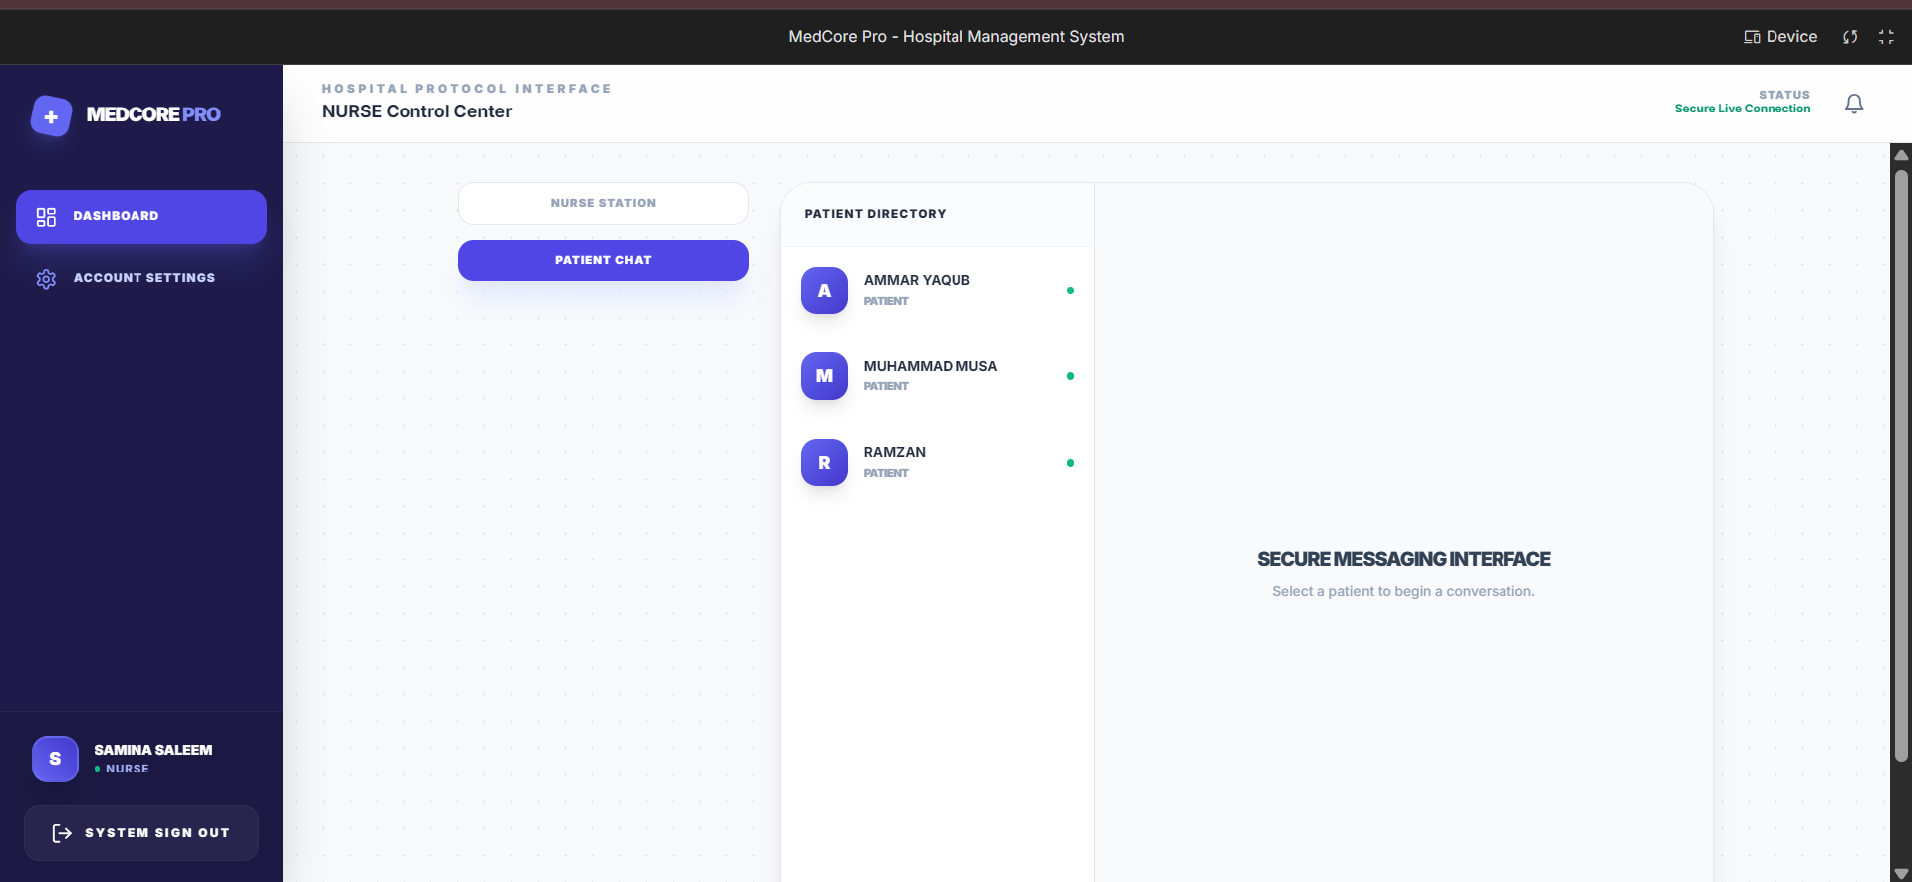

ACCOUNTANT LOGIN :
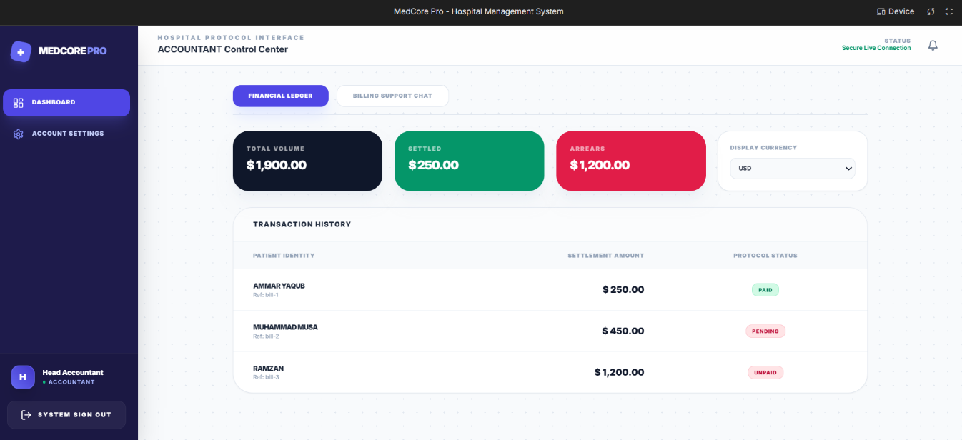
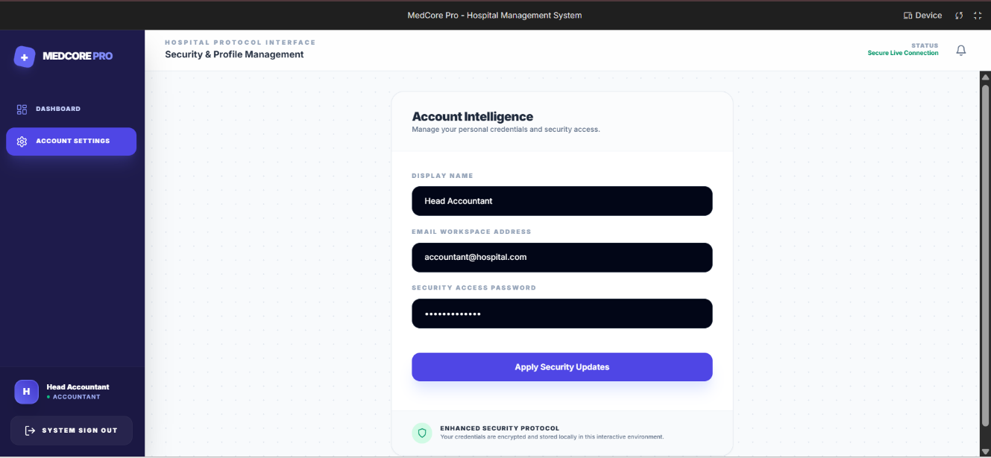
CLINIST LOGIN :
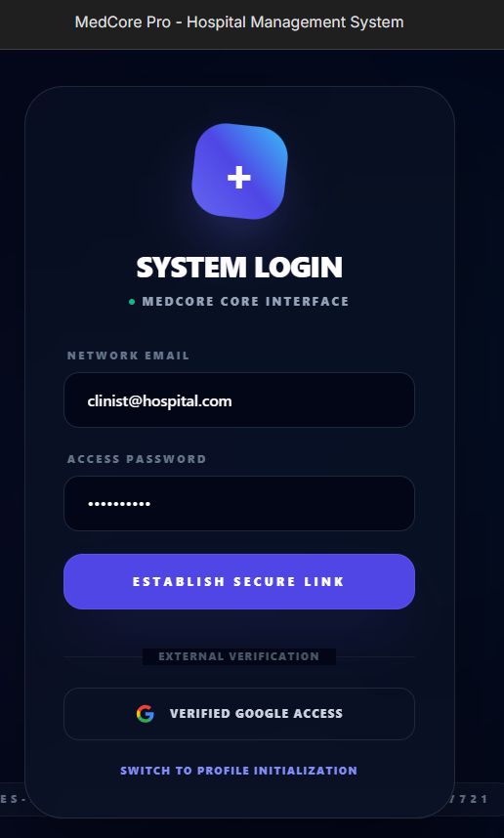
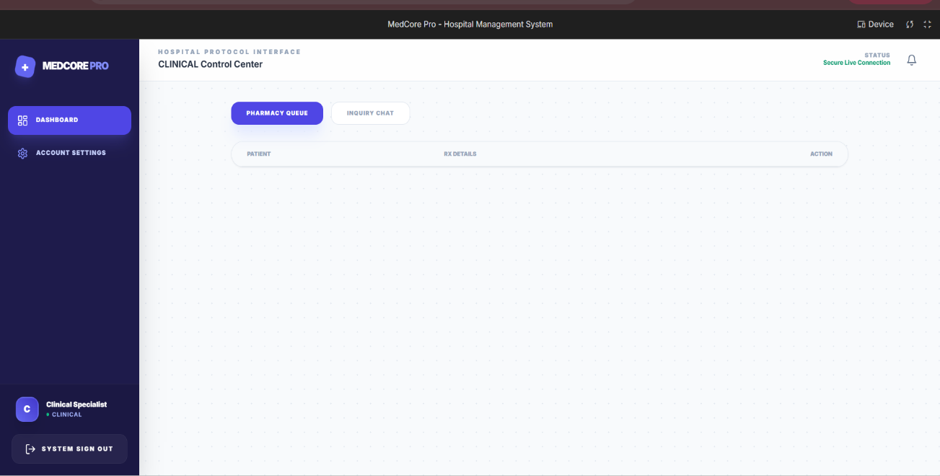
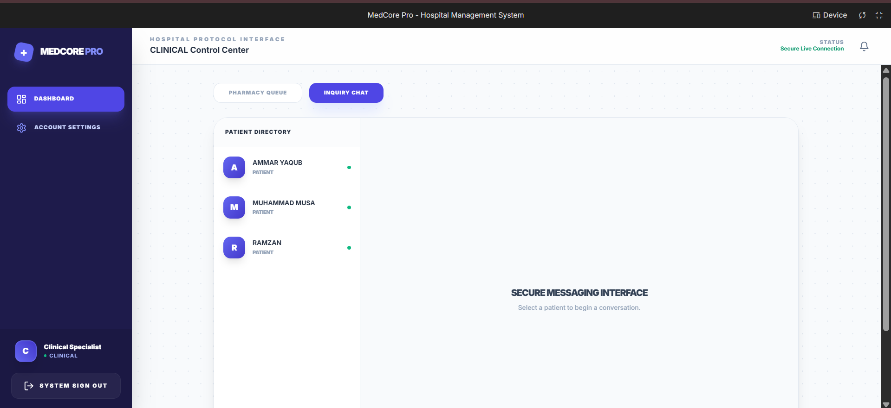
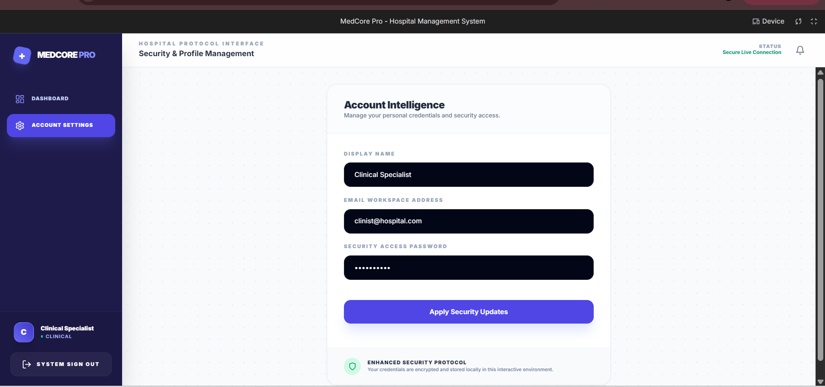

PATIENT LOGIN :
